EEE 120
Simulation Lab 4 Answer Sheet
The Microprocessor
Name: Anish Katukam
Date: 3/27/18
Task 4-1: Build the Addressing Logic
Include a picture of your Logisim addressing logic circuit here:
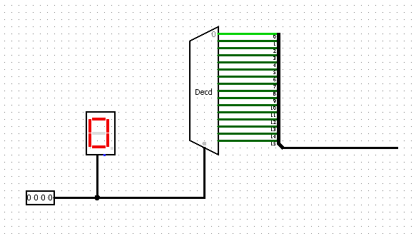

Task 4-2: Build a 4-Bit ROM Memory Cell
Include a picture of your Logisim 4-bit ROM circuit here:
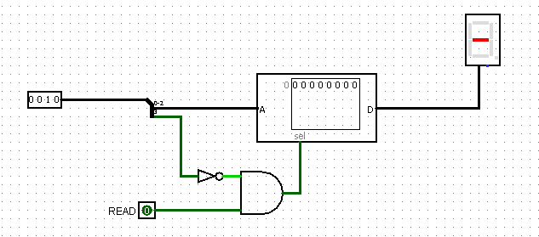

Task 4-3: Build 4-Bit Output Port
Include a picture of your Logisim 4-bit output port circuit here:
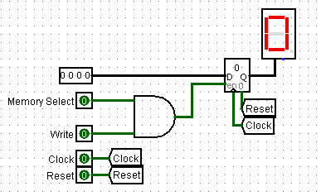

Test your circuit and record the results in Table .
Table 1
Data Bus (4-bit binary) | Write | Memory Select | Q
1101 | 1 | 1 | d
0001 | 0 | 1 | d
0001 | 1 | 1 | 1
1100 | 1 | 1 | C

Task 4-4: Build the 4-Bit RAM Cell
Include a picture of your Logisim 4-bit RAM circuit here:
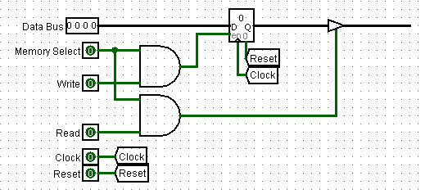

Test your circuit and record the results in Table . Include a picture of your Logisim 4-bit RAM circuit testing set up.
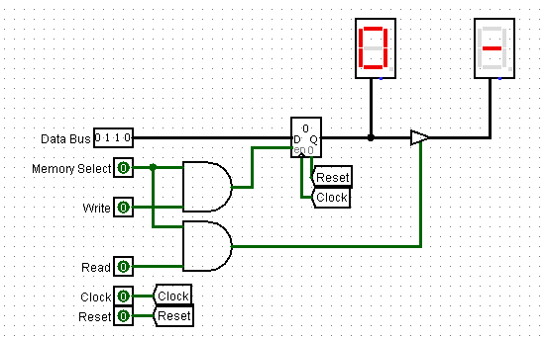
Table 2
Data Bus  (4-bit binary) | Write | Memory Select | Read | Q {between register and buffer} | Data Bus {after buffer}
0111 | 0 | 1 | 0 | 7 | -
0111 | 0 | 1 | 1 | 7 | 7
0110 | 1 | 1 | 1 | 6 | 6
1111 | 1 | 1 | 0 | f | -
1111 | 0 | 1 | 1 | f | f
1001 | 1 | 1 | 0 | f | -

Task 4-5: Build the Brainless Central Processing Unit
Include a picture of your Logisim Brainless Central Processing Unit circuit here:
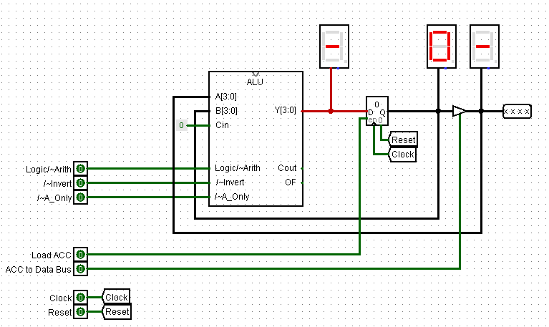

Task 4-6: Build the Brainless Microprocessor
Include a picture of your Logisim brainless microprocessor circuit here:
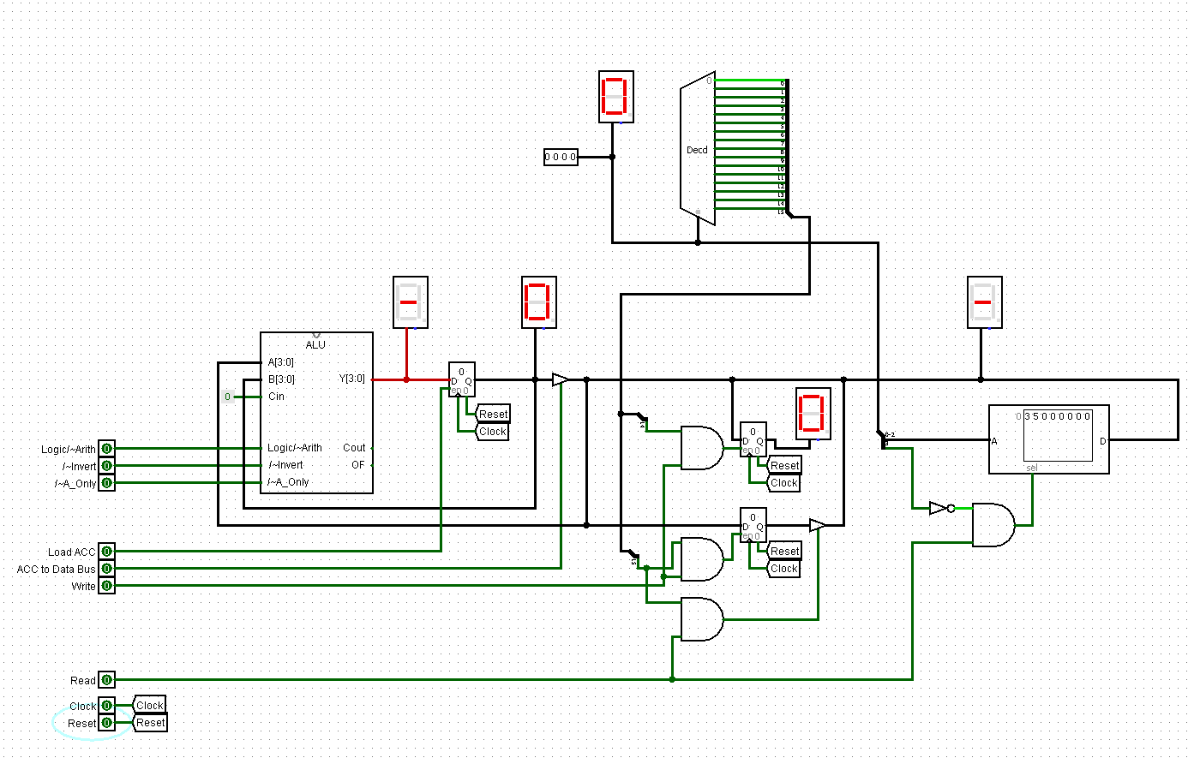

Task 4-7: Testing and Controlling the Brainless Microprocessor
Follow steps 1 through 3 outlined in the laboratory manual to test your brainless microprocessor circuit. It might be helpful to review the ALU Function Table from Sim lab 3. Table 3 is an example, for the ADD command, of how to fill out tables to record the values of the control lines during every clock cycle.
Table 3
Instruction [ Add operand to Accumulator (ACC) ]
Control Line | Value
4-bit Binary Keyboard (Address Bus) | Address of operand
Write | 0
Read | 1
ACC to Data Bus | 0
Load ACC | 1
/~A_Only | 1
/~Invert | 1
Logic/~Arith | 0

For all of the instructions you performed (i.e. Subtract, Load ACC, etc.) record the values of the control lines during every clock cycle in Table 4 and Table 5.

Table 4
Instruction [ Load ACC with operand ]
Control Line | Value
4-bit Binary Keyboard (Address Bus) | 0000
Write | 0
Read | 1
ACC to Data Bus | 0
Load ACC | 1
/~A_Only | 0
/~Invert | 1
Logic/~Arith | 0
Instruction [AND operand with ACC]
Control Line | Value
4-bit Binary Keyboard (Address Bus) | 0000
Write | 0
Read | 1
ACC to Data Bus | 0
Load ACC | 1
/~A_Only | 1
/~Invert | 1
Logic/~Arith | 1
Instruction [ Store ACC to RAM ]
Control Line | Value
4-bit Binary Keyboard (Address Bus) | 1111
Write | 1
Read | 0
ACC to Data Bus | 1
Load ACC | 0
/~A_Only | 0
/~Invert | 0
Logic/~Arith | 0
Instruction [ Subtract operand from ACC ]
Control Line | Value
4-bit Binary Keyboard (Address Bus) | 1111
Write | 1
Read | 0
ACC to Data Bus | 0
Load ACC | 1
/~A_Only | 1
/~Invert | 0
Logic/~Arith | 0

Describe any other tests that you performed. NOTE: the laboratory manual gives you a minimum set of items to test
Table 5
Instruction [ Not (operand) to ACC ]
(1’s complement)
Control Line | Value
4-bit Binary Keyboard (Address Bus) | 1111
Write | 1
Read | 0
ACC to Data Bus | 0
Load ACC | 1
/~A_Only | 0
/~Invert | 0
Logic/~Arith | 1
Instruction [ Negate(operand) to ACC ]
(2’s complement)
Control Line | Value
4-bit Binary Keyboard (Address Bus) | 1111
Write | 1
Read | 0
ACC to Data Bus | 0
Load ACC | 1
/~A_Only | 0
/~Invert | 0
Logic/~Arith | 0

Why do you think the register at the output of the ALU is called the ‘accumulator’?
It is where results of the ALU accumulate.
Task 4-8: Build the Memory-Address-Generation Circuit
Include a picture of your Logisim memory address generation circuit here:
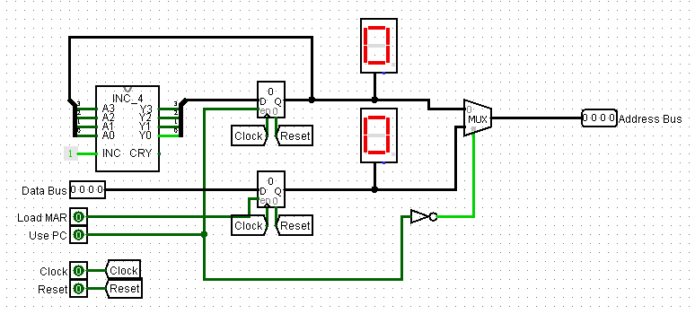
Task 4-9: Build the Controller Circuit
Include a picture of your Logisim controller circuit here:
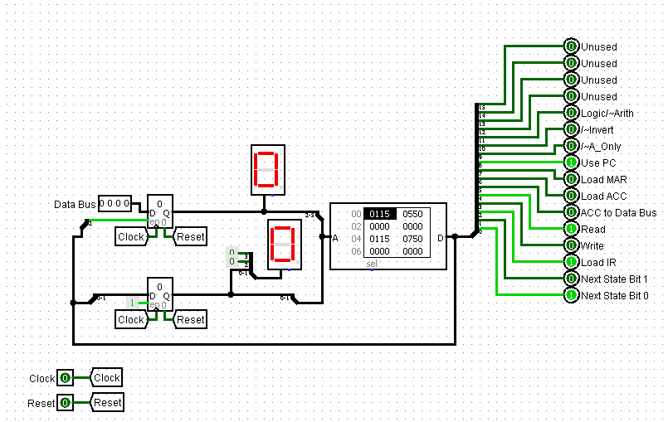

Task 4-10: Build the Complete Microprocessor Circuit
Include a picture of your Logisim complete microprocessor circuit, with controller, here:
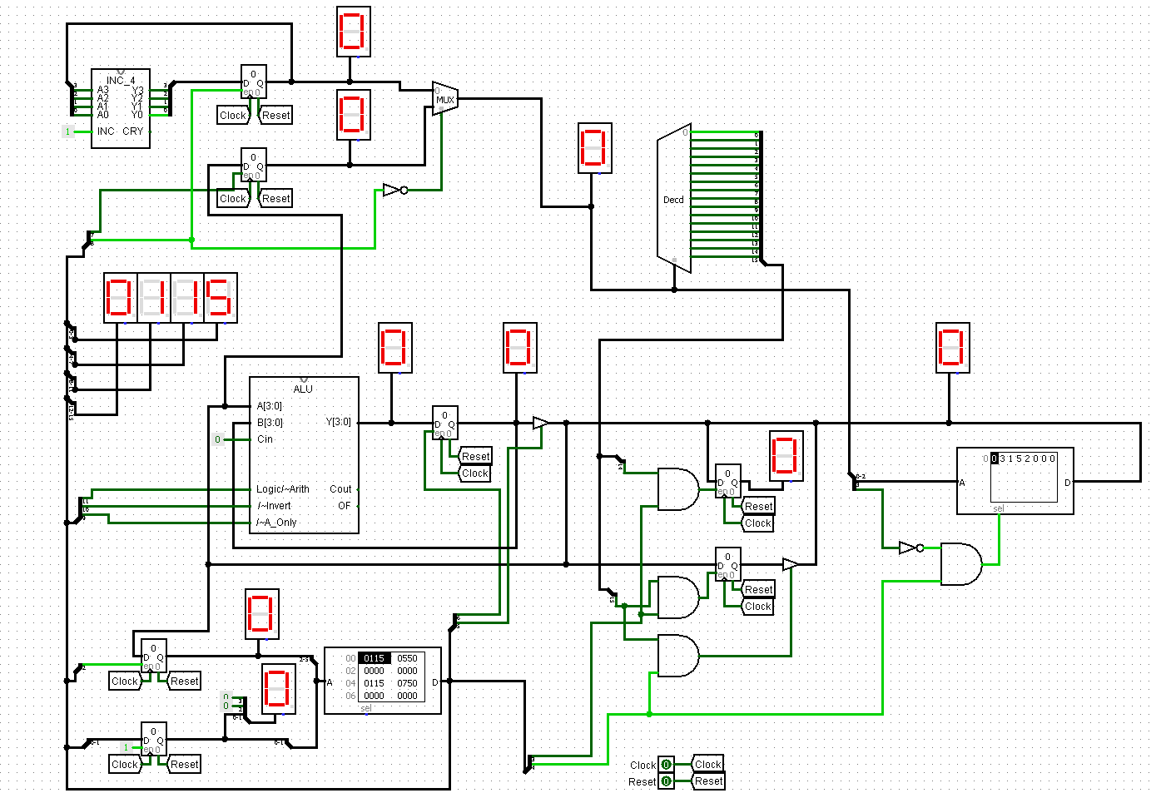
Task 4-11: Write and Execute a Simple Program for Your Microprocessor
Write the program given in your laboratory manual into the appropriate memory locations. Observe the operation of each step of your program (i.e. observe the values of the control lines and record whether data is being moved properly according to those control line settings). Did you get an 8 stored into the accumulator with you initial test?
If not, what error(s) did you find during your debugging process?
Yep! Worked on the first try.

Task 4-12: Add the ‘AND’, ‘Zero’, ‘Subtract’, and ‘Store ACC’ Instructions
Use Table 6 and Table 7 to enter your values into the microinstruction definition table for each of the four instructions asked for in the laboratory manual. Be sure to label the name of each and every instruction.
Table 6
 | Instruction | AND |  |  |  | ZERO
 | Opcode | 3 |  |  |  | 4
 | Pres. State | 00 | 01 | 02 | 03 | 00 | 01 | 02 | 03
Description | Pin number
Next State Bits | 1-0 | 1 | 0 |  |  | 1 | 0
Load IR | 2 | 1 | 0 |  |  | 1 | 0
Write | 3 | 0 | 0 |  |  | 0 | 0
Read | 4 | 1 | 1 |  |  | 1 | 0
ACC to Data Bus | 5 | 0 | 0 |  |  | 0 | 1
Load ACC | 6 | 0 | 1 |  |  | 0 | 1
Load MAR | 7 | 0 | 0 |  |  | 0 | 0
Use PC | 8 | 1 | 1 |  |  | 1 | 0
/~A_only | 9 | 0 | 1 |  |  | 0 | 1
/~Invert | 10 | 0 | 1 |  |  | 0 | 0
Logic/~Arith | 11 | 0 | 1 |  |  | 0 | 0
X | 12 | 0 | 0 |  |  | 0 | 0
X | 13 | 0 | 0 |  |  | 0 | 0
X | 14 | 0 | 0 |  |  | 0 | 0
X | 15 | 0 | 0 |  |  | 0 | 0
 | HEX equiv | 0115 | 0f50 |  |  | 0115 | 0260

Table 7
 | Instruction | SUBTRACT |  |  |  | STORE ACC
 | Opcode | 5 |  |  |  | 6
 | Pres. State | 00 | 01 | 02 | 03 | 00 | 01 | 02 | 03
Description | Pin number
Next State Bits | 1-0 | 1 | 0 |  |  | 1 | 1 | 0
Load IR | 2 | 1 | 0 |  |  | 1 | 0 | 0
Write | 3 | 0 | 0 |  |  | 0 | 0 | 1
Read | 4 | 1 | 1 |  |  | 1 | 1 | 0
ACC to Data Bus | 5 | 0 | 0 |  |  | 0 | 0 | 1
Load ACC | 6 | 0 | 1 |  |  | 0 | 0 | 0
Load MAR | 7 | 0 | 0 |  |  | 0 | 1 | 0
Use PC | 8 | 1 | 1 |  |  | 1 | 1 | 0
/~A_only | 9 | 0 | 1 |  |  | 0 | 0 | 0
/~Invert | 10 | 0 | 0 |  |  | 0 | 0 | 0
Logic/~Arith | 11 | 0 | 0 |  |  | 0 | 0 | 0
X | 12 | 0 | 0 |  |  | 0 | 0 | 0
X | 13 | 0 | 0 |  |  | 0 | 0 | 0
X | 14 | 0 | 0 |  |  | 0 | 0 | 0
X | 15 | 0 | 0 |  |  | 0 | 0 | 0
 | HEX equiv | 0115 | 0350 |  |  | 0115 | 0192 | 0028

Test your instructions by writing and executing programs. Record at least four programs and the output of each program in tables like that of Table 8.
Table 8
Program #0 ( Example: ADD = 3+5)
Address | Value | Operation (In English)
0 | 0 | The 'Load ACC' Opcode
1 | 3 | The number '3' to be loaded into the Accumulator
2 | 1 | The 'Add to ACC' Opcode
3 | 5 | The number '5' to be added to the Accumulator
4 | 2 | The 'Stop' Opcode
What was the final output of your program? ___8__
Was the program successful? YES_
If not what error(s) did you find in your circuit?

Program # (AND 2 and 3 )
Address | Value | Operation (In English)
0 | 0 | Load ACC
1 | 2 | Constant
2 | 3 | ADD with ACC
3 | 3 | Constant
4 | 2 | Stop
What was the final output of your program? _2____
Was the program successful? Yes
If not what error(s) did you find in your circuit?

Program # (Zero)
Address | Value | Operation (In English)
0 | 0 | Load ACC
1 | 2 | Load 2 into ACC
2 | 4 | Zero ACC
3 | 2 | Stop
What was the final output of your program? 0
Was the program successful? Yes
If not what error(s) did you find in your circuit?

Program # ( Subtract 2-1 )
Address | Value | Operation (In English)
0 | 0 | Load ACC
1 | 2 | Load 2 into ACC
2 | 5 | Subtract ACC
3 | 1 | Constant
4 | 2 | Stop
What was the final output of your program? 1
Was the program successful? Yes
If not what error(s) did you find in your circuit?

Program # ( Store 1 to RAM )
Address | Value | Operation (In English)
0 | 0 | Load ACC
1 | 1 | Constant
2 | 6 | Store ACC to RAM
3 | 15 | Memory Address
4 | 2 | Stop
What was the final output of your program? 1 stored in RAM
Was the program successful? Yes
If not what error(s) did you find in your circuit?

Task 4-13: Invent Your Own Instruction (Extra Credit)
Fill in the following two tables for your invented instruction.
 | Instruction
 | Opcode | 7
 | Pres. State | 00 | 01 | 02 | 03 | 00 | 01 | 02 | 03
Description | Pin number
Next State Bits | 1-0
Load IR | 2
Write | 3
Read | 4
ACC to Data Bus | 5
Load ACC | 6
Load MAR | 7
Use PC | 8
/~A_only | 9
/~Invert | 10
Logic/~Arith | 11
X | 12
X | 13
X | 14
X | 15
 | HEX equiv

Program # ( )
Address | Value | Operation (In English)
What was the final output of your program? _____
Was the program successful? Yes or No_
If not what error(s) did you find in your circuit?

Simulation Lab 4: Lab Report Grade Sheet

Name:

Grading Criteria | Max Points | Points Lost
Template
Neatness, Clarity, and Concision | 2
Description of Assigned Tasks, Work Performed & Outcomes Met
Task 4-1: Build the Addressing Logic | 2
Task 4-2: Build a 4-Bit ROM Memory with eight cells | 3
Task 4-3: Build 4-Bit Output Port | 2
Task 4-4: Build the 4-Bit RAM Cell | 2
Task 4-5: Build the Brainless Central Processing Unit | 5
Task 4-6: Build the Brainless Microprocessor | 6
Task 4-7: Test and Control the Brainless Microprocessor | 8
Task 4-8: Build the Memory-Address-Generation Circuit | 3
Task 4-9: Build the Controller Circuit | 6
Task 4-10: Build the Complete Microprocessor Circuit | 6
Task 4-11: Write and Execute a Simple Program for your Microprocessor | 3
Task 4-12: Add the ‘AND’, ‘Zero’, ‘Subtract’, and ‘Store ACC’ Instructions | 12
Task 4-13: Invent Your Own Instruction | (3 extra points)
Self-Assessment Worksheet (The content of the self-assessment worksheet will not be graded. Full credit is given for including the completed worksheet.) | (2 extra points)
 | Points Lost
Lab Score (60 points total) | Late Lab
 | Lab Score

Self-Assessment Worksheet

Put ‘X’s’ in the table below indicating how strongly you agree or disagree that the outcomes of the assigned tasks were achieved. Use ‘5’ to indicate that you ‘strongly agree’, ‘3’ to indicate that you are 'neutral', and ‘1’ to indicate that you ‘strongly disagree’. Use ‘NA’, ‘Not Applicable’, when the tasks you performed did not elicit this outcome. Credit will be given for including this worksheet with your lab report; however, your responses will not be graded. They are for your instructor’s information only.
Table __: Self-Assessment of Outcomes for Simulation Lab 4: The Microprocessor
After completing the assigned tasks and report, I am able to: | 5 | 4 | 3 | 2 | 1 | NA
Build, debug and control a simulation of a ROM, RAM and an output port.
Build and debug a simulation of a microprocessor that is absent a controller.
Act as the controller for an elementary microprocessor.
Design a PROM-based controller for an elementary microprocessor.
Create an instruction set for an elementary microprocessor.
Use the language of your instruction set to create a program and enter it into memory.
Execute a program on your simulated microprocessor.

Write below any suggestions you have for improving this laboratory exercise so that the stated learning outcomes are achieved.

